**Internet Explorer**

**Mozilla Firefox**

**Apple Safari**

**Google Chrome**

**Internet Explorer**

**Internet Explorer 8**

1. **Once your browser is open, click the Tools menu**. Or, optionally you may simply press Ctrl+Shift+Delete to open the Delete Browsing History window (and skip step 2).
2. Click on **Internet Options.**

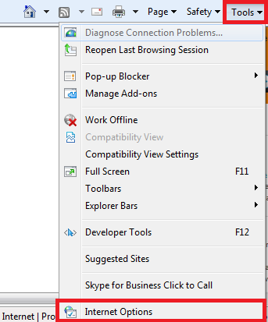

1. Click on **Delete** under the **Browsing history** option.

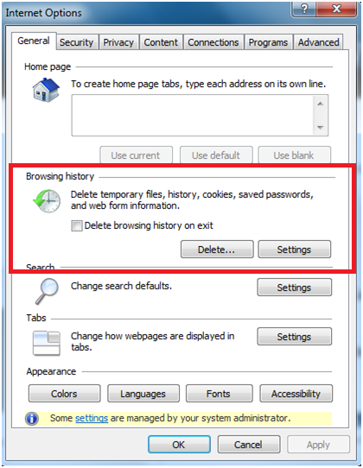

1. Select **Temporary Internet Files** and **Cookies**.

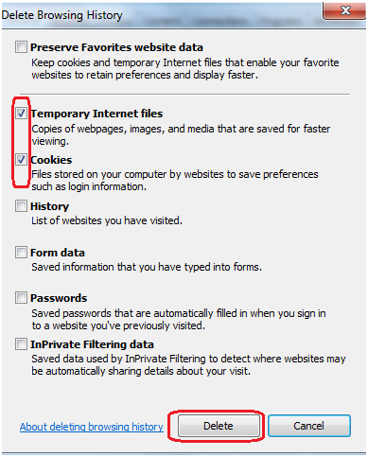

1. Click the **Delete** button near the bottom of the window to delete your temporary files (i.e. clear your cache).

**Internet Explorer 9, 10 and 11**

1. Open the browser by clicking the ‘**e**’ logo on your desktop or task bar.
2. In the upper right hand corner of the browser, click the icon that looks like a small gear which is the “**Tools**” button. Or, optionally you may simply press Ctrl+Shift+Delete to open the Delete Browsing History window (and go to step 5).

**C:\Users\eradichkova\Desktop\To Upload\KOs\C&C\Untitled.png**

1. Hoover your mouse cursor over the **Safety** link.
2. Click on “**Delete Browsing History…”**

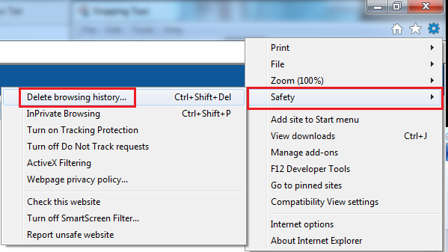

1. Place a check mark in the boxes **Temporary internet files** and **Cookies.**
2. After selecting the boxes, press the “**Delete**” button.

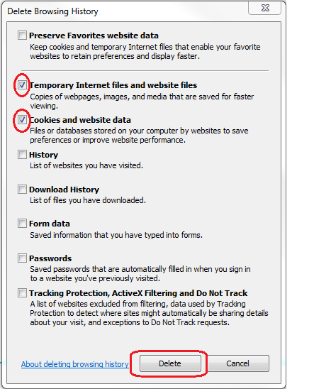

1. You should see a notice at the bottom of the page stating that the selected browsing history has been cleared.
2. Close and reopen your browser.

**Note:** IE has a "feature" which retains some cookies even after you clear your cache if you do not **uncheck** the **"Preserve Favorites Website Data."**

**Always uncheck this option to completely clear all the cache & cookies.**

**Mozilla Firefox**

**Firefox 24+**

1. Open **Firefox**.
2. Click the menu button and choose **History**. *If the menu is not visible, hit the ALT key on your keyboard.*



1. Select **Clear Recent History.**

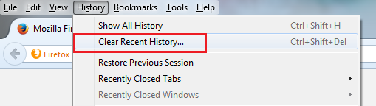

1. From the **“Time range to clear”** dropdown select **Everything**.
2. If necessary, expand the **Details** section.
3. Click to select **Cache & Cookies**.
4. Click **Clear Now**.
5. Click **OK**.

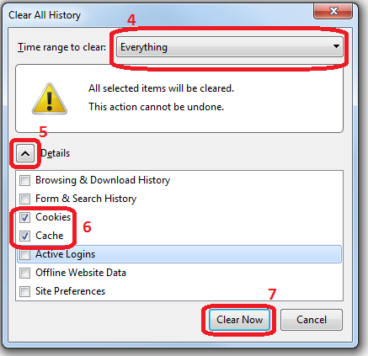

1. The progress wheel may spin for a few minutes, depending on how much data needed to be deleted. Once it has stopped, the process is complete.
2. Close and reopen the browser.

**Firefox 21+ for Macintosh**

1. In the menu bar click **History**
2. Select **Clear Recent History**

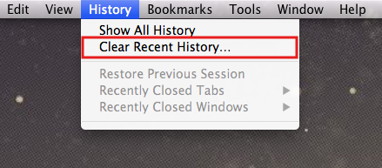

1. In the window that appears, click on the dropdown menu to the right of Time range to clear and select **Everything**.
2. If necessary, expand the **Details** section.
3. Check both **Cookies** and **Cache**.
4. Click **Clear Now**.

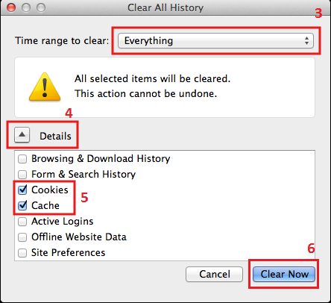

1. The progress wheel may spin for a few minutes, depending on how much data needed to be deleted. Once it has stopped, the process is complete.
2. Close and reopen the browser.

**Apple Safari**

1. Click **Safari** in the upper left hand side of your screen.
2. In the menu that appears, click **Preferences**.

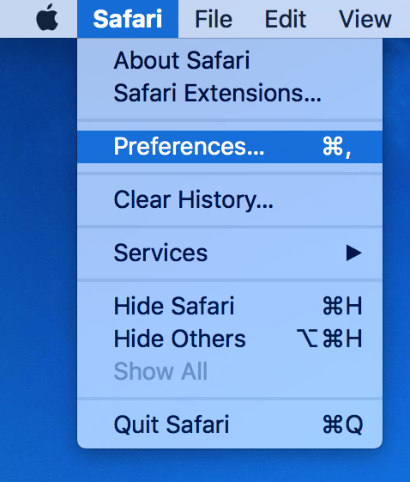

1. In the window that appears, click the **Privacy** tab.
2. Click the button **Remove All Website Data...**.

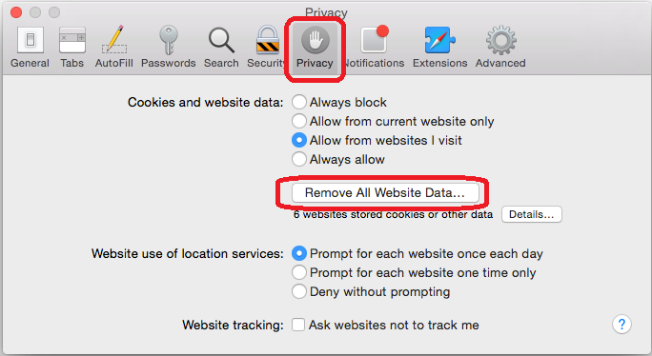

1. Click **Remove Now** in the pop up window that appears.

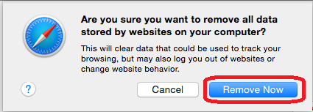

1. Close and reopen the browser.

**Google Chrome**

**Chrome for Windows**

1. Open **Chrome**
2. Expand the Chrome menu.
3. Point to **More Tools**.
4. Click **Clear browsing data**

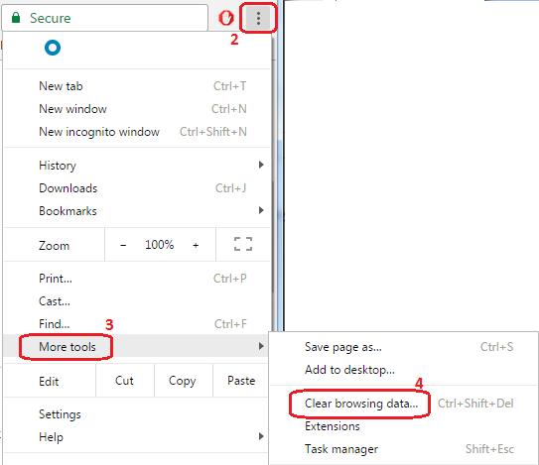

1. In the **“Clear browsing data”** box, click the checkboxes for **Cookies and other site and plug-in data** and **Cached images and files**.
2. Choose “**Beginning of time**” to delete everything.
3. Click **Clear browsing data**.

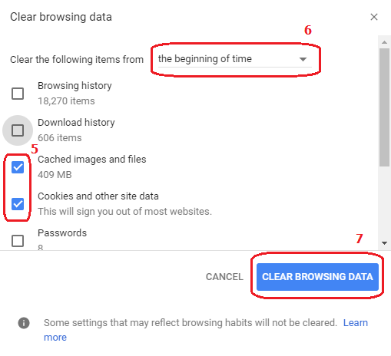

1. Close and reopen the browser.

**Chrome for Macintosh**

1. Click on **Chrome** > **Clear Browsing Data...**.

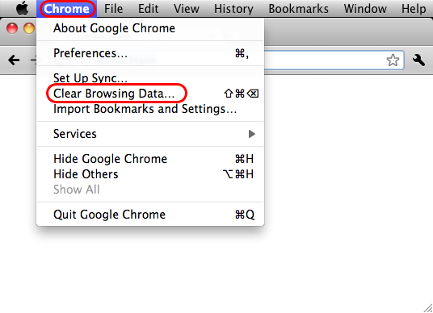

1. Select **Empty the Cache** and **Delete Cookies and other site data.**
2. Select **the beginning of time** in the drop down box
3. Click on the **Clear Browsing Data** button.

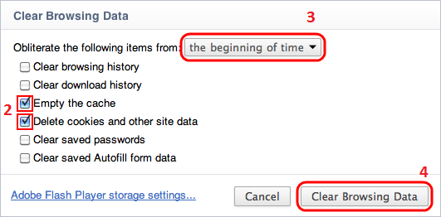

1. Close and reopen the browser.